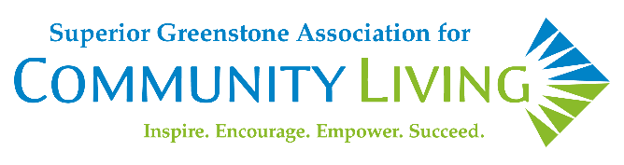
Superior Greenstone Association for Community Living
Supports & Services Supervisor - Job Description

Superior Greenstone Association for Community Living (SGACL) provides person-centred community and residential supports to people who have a developmental disability.
Our Vision: A Meaningful Life: Community. Relationships. Joy. Well-Being.
Our Mission: Inspire. Encourage. Empower. Succeed.
Job Function
The Supports & Services Supervisor will provide a leadership role for front line support staff in the fulfillment of their responsibilities; provides support, guidance and direction in a professional manner; ensures that quality supports are provided within available resources, in accordance with the Vision, Mission, Goals and Objectives of the Association. A hybrid work model may be considered for this position that balances in-person community engagement with remote work options. The Supports & Services Supervisor must be able to commute and be on-site on a weekly basis to meet the needs of people supported and their support staff. Specific arrangements and operational needs can be discussed further during the application process.
Qualifications
- Diploma or degree in the Human Services field and/or an equivalent combination of education and related experience.
- At least two years in a supervisory or management position in the field of developmental or human services, and/or several years of working experience supporting people with a developmental disability.
- Previous experience providing meaningful supports, as well as knowledge of administering medication is required.
- Excellent oral and written communication skills are required.
- Demonstrated skills in leadership, interpersonal relations, organization and time management.
- Ability to work independently while being capable of collaboration with a team.
- Ability to travel for business needs.
- The successful candidate must be able to work flexible hours as dictated by needs of the people supported.
- Proficiency in both English and French is considered an asset (but not a requirement) as many communities in the SGACL catchment area are designated under the French Language Services (FLS) Act.
- Valid driver’s license, as well as usage of a reliable, personal vehicle will be required.
- Positive Reference checks (personal, professional and criminal) are required.
- Ability to obtain a clean vulnerable sector check.
- Valid First Aid & CPR Certification.
- A commitment to organizational values and proficiency in exercising sound judgment.
- Excellent verbal, non-verbal and written communication skills, along with basic computer literacy.
Job Duties & Responsibilities of the Supports & Services Supervisor:
- Supervision of team members.
- Conducts continuous and ongoing evaluations of team members through performance appraisals, as well as meeting with team members regularly.
- Carries out progressive discipline as required by policy and the Collective Agreement(s).
- Fosters team-building and a positive working relationship that enhances team performance.
- Annually develops budgets and a comprehensive list of needs to operate each program through meetings with team members.
- Determines staffing needs and efficiency of resources through staff planning, including developing advanced schedules, specialized training, hiring process, orientation, etc.
- Performs On-Call/Emergency duties on rotational basis as required.
- Performs personal planning, ensuring team members are advocating and providing daily medical, emotional and physical supports.
- Involvement in Committee Membership as required.
- Adheres to and follows all agency policies and procedures as well as participates in review, revision and development.
- Follows up with household management, as well as corrective actions.
- Participates in health & safety procedures under the Ontario Health & Safety Act (OHSA).
- Interprets, implements and adheres to the Collective Agreement(s).
- Completes and follows-up with incident reporting.
- Maintains professionalism through working knowledge of events, services, community supports and resources available to the people we serve.
- Other duties as assigned.
Physical Requirements
- Physical ability to safely support the mobility and transfers of people we serve, including the use of appropriate assistive devices and techniques.
- Ability to assist with wheelchair mobility, including pushing and pulling.
- Standing, sitting, and walking for extended periods of time.

Shifts: Forty (40) hours per week Monday to Friday. Subject to change as needed.
Starting Date: May 1st, 2026.
Wage Range: $75,649.60 annual salary.
Please send your application to: Chelsea Methot
HR Advisor
Superior Greenstone Association for Community Living
info@sgacl.ca
Posting Date: April 2nd, 2026.
Closing Date: April 15th, 2026.

